FleetWise - Application Description and Use Cases
Vivek Chaurasia vivekc03@umd.edu
UMD Directory ID: 120980275

Contents

1 Application Description |  |  |  |  | 2
2 Use Cases |  |  |  |  | 2
2.1 Use Case 1: Add New Vehicle to Fleet |  |  |  | . . . . . . . . . . . . . . . . . . . | 2
2.2 |  | Use Case 2: | Check Vehicle Availability via Chatbot . . . . . . . . . . . . |  | 3
2.3 |  | Use Case 3: | Process Vehicle Reservation . . . . . . . . . . . . . . . . . . |  | 3
2.4 |  | Use Case 4: | Return Reserved Vehicle . . . . . . . . . . . . . . . . . . . . |  | 4
2.5 |  | Use Case 5: | Remove Vehicle from Fleet . . . . . . . . . . . . . . . . . . . |  | 5
3 | Actor Interaction Diagrams |  |  |  | 6
 | 3.1 Figure 1: Complete System Use Case Overview . . . . . . . . . . . . . . |  |  |  | 7
 | 3.2 Figure 2: Fleet Manager Use Cases . . . . . . . . . . . . . . . . . . . . . |  |  |  | 8
 | 3.3 Figure 3: Fleet User Use Cases . . . . . . . . . . . . . . . . . . . . . . . |  |  |  | 9
4 | References |  |  |  | 10

- Application Description
FleetWise is a web-based vehicle fleet management system designed to streamline cor- porate transportation operations. The application provides a centralized platform where fleet managers can manage vehicle inventory while fleet users can check availability and manage their reservations.
The system serves Fleet Managers who handle administrative tasks like adding vehi- cles and processing reservations, and Fleet Users who need to check vehicle availability through the integrated chatbot system. The chatbot guides users through manufacturer and model selection to provide instant availability status.
FleetWise maintains records of fleet vehicles including manufacturer, model, and li- cense plate information. The system enforces a three-vehicle reservation limit per fleet user and eliminates manual scheduling processes that create inefficiencies in traditional fleet operations.

Use Cases
  - Use Case 1: Add New Vehicle to Fleet Title: Add New Vehicle to Corporate Fleet Inventory
Actor: Fleet Manager
Goal: Successfully register a newly acquired vehicle in the fleet management system

Steps (Happy Path):
    - Fleet Manager accesses the vehicle management section of the system
    - Fleet Manager selects the “Add New Vehicle” option
    - System displays a vehicle registration form
    - Fleet Manager enters the vehicle’s manufacturer, model, and license plate number
    - Fleet Manager submits the completed registration form
    - System validates the entered vehicle information
    - System adds the vehicle to the corporate fleet inventory
    - System displays a confirmation message with the vehicle’s details
    - The new vehicle becomes immediately available for fleet user reservations

Error Scenarios:
      - If the license plate already exists in the system, manager is notified of the duplicate
      - If required fields are missing, the form highlights the incomplete sections
      - If the system is temporarily unavailable, manager receives a retry message

Use Case 2: Check Vehicle Availability via Chatbot
Title: Inquire About Vehicle Availability Using Guided Chatbot
Actor: Fleet User
Goal: Quickly determine if specific types of vehicles are available for reservation

Steps (Happy Path):
    - Fleet User accesses the chatbot interface
    - Chatbot presents manufacturer selection buttons (Honda, Toyota, Ford, etc.)
    - Fleet User clicks on desired manufacturer button
    - Chatbot displays available model options for the selected manufacturer
    - Fleet User selects specific model from the presented options
    - Chatbot searches the fleet inventory for the requested vehicle
    - Chatbot responds with current availability status for that vehicle type
    - If available, chatbot confirms the vehicle can be reserved
    - If currently rented, chatbot provides expected return information

Error Scenarios:
      - If the selected manufacturer has no vehicles in the fleet, chatbot explains this and offers alternatives
      - If the selected model is not available, chatbot suggests similar models from the same manufacturer
      - If all vehicles are currently reserved, chatbot provides information about upcoming availability
  - Use Case 3: Process Vehicle Reservation Title: Reserve Available Vehicle for Fleet User Use
Actor: Fleet Manager
Goal: Successfully assign an available vehicle to a fleet user for business use

Steps (Happy Path):
    - Fleet User approaches Fleet Manager with vehicle reservation request
    - Fleet Manager accesses the reservation management system
    - Fleet Manager searches for the requested vehicle type in the system
    - System confirms the vehicle is available for reservation
    - Fleet Manager verifies fleet user’s current reservation count (maximum 3 vehicles)
    - Fleet Manager enters the fleet user’s identification information
    - Fleet Manager processes the reservation transaction

    - System updates the vehicle’s status to “rented”
    - System records the reservation details and fleet user information
    - System provides reservation confirmation with vehicle details and keys location

Error Scenarios:
      - If the requested vehicle is already reserved, manager offers alternative vehicles
      - If fleet user has reached maximum reservation limit (3 vehicles), manager explains the restriction
      - If fleet user identification cannot be verified, manager requests additional documen- tation
  - Use Case 4: Return Reserved Vehicle Title: Process Vehicle Return from Fleet User
Actor: Fleet User and Fleet Manager
Goal: Successfully return a previously reserved vehicle and update system records

Steps (Happy Path):
    - Fleet User returns with the reserved vehicle to the fleet location
    - Fleet Manager receives the returned vehicle and keys
    - Fleet Manager accesses the return processing system
    - Fleet Manager enters the vehicle’s license plate number
    - System locates the active reservation record for this vehicle
    - System confirms the vehicle was reserved to the returning fleet user
    - Fleet Manager conducts basic vehicle condition check
    - Fleet Manager processes the return transaction
    - System updates the vehicle’s status to “available”
    - System removes the vehicle from the fleet user’s active reservation list

Error Scenarios:
      - If the vehicle shows damage, manager documents the condition before processing return
      - If the vehicle wasn’t reserved to the returning fleet user, manager investigates the discrepancy
      - If the vehicle has maintenance issues, manager marks it for service before making it available

Use Case 5: Remove Vehicle from Fleet
Title: Decommission Vehicle from Corporate Fleet Inventory
Actor: Fleet Manager
Goal: Permanently remove a vehicle from the fleet’s digital and physical inventory

Steps (Happy Path):
    - Fleet Manager identifies a vehicle that needs to be removed from the fleet
    - Fleet Manager accesses the vehicle management system
    - Fleet Manager searches for the specific vehicle using license plate number
    - System displays the vehicle’s current status and reservation history
    - Fleet Manager verifies the vehicle is not currently reserved
    - Fleet Manager selects the “Remove Vehicle” option
    - System requests confirmation for the permanent removal
    - Fleet Manager confirms the decommission decision
    - System permanently removes the vehicle from the fleet inventory
    - System updates fleet counts and generates removal confirmation

Error Scenarios:
      - If the vehicle is currently reserved, system prevents removal until it’s returned
      - If the vehicle has pending reservations, manager is notified before proceeding
      - If removal would affect historical records, system requests additional confirmation

Actor Interaction Diagrams
Diagrams attached over the next three pages.

Figure 1: Complete System Use Case Overview
7
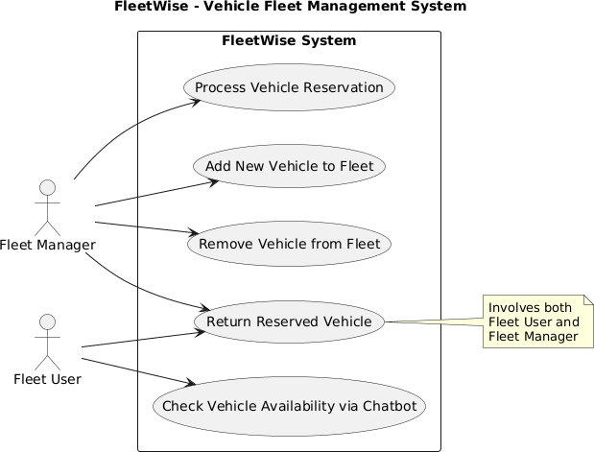

8

  - Figure 2: Fleet Manager Use Cases
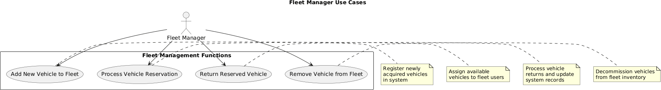

Figure 2: Fleet Manager Use Cases

9

Figure 3: Fleet User Use Cases
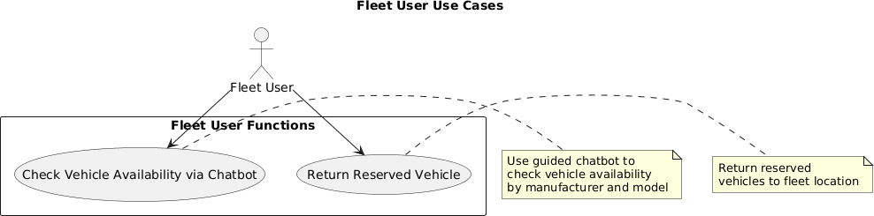

Figure 3: Fleet User Use Cases

References
- Johnson, R.M., “Corporate Fleet Management: Digital Transformation in Trans- portation Services,” Fleet Management Quarterly, vol. 34, no. 2, pp. 45–62, 2020.
- Anderson, K.L. and Peterson, S.J., “Automated Vehicle Tracking Systems: Imple- mentation Strategies for Medium-Scale Fleets,” Transportation Technology Review, vol. 28, no. 4, pp. 112–128, 2019.
- Williams, D.A., “Employee Self-Service Systems in Fleet Operations: Reducing Administrative Overhead Through Technology,” Corporate Transportation Journal, vol. 15, no. 3, pp. 78–85, 2020.
- Chen, M.H., “Digital Asset Management in Corporate Vehicle Fleets: Current Trends and Best Practices,” Business Operations Technology, vol. 42, no. 1, pp. 234–249, 2021.
- Thompson, L.R., “User Experience Design in Fleet Management Applications: A Comparative Analysis,” Applied Transportation Systems, vol. 19, no. 2, pp. 156– 171, 2020.

10

